## CS/SF 495-01

## Weekly Report

Name ____________________ Date:_____29/08/2022_____

Hours worked this week: ___7hours_______ Total hours worked: ___7 hours___

**Project Plan timeline activity for this week:**

On this week I identified the various program layout structures I could emulate for the TO DO List project and also what features could be mapped into the layout. Since I worked on python and C# before, I chose python since I would like to improve my skills and know more about the Python Language. Python framework seemed to have a suitable layout that I could use to map the features. Takin gto account that we need a prioritied to Do list, the layout would ned to have the various features to priotize, delete and archive the events created. Therefore, each event would need an actual category, which will represent the priorities of the events. On the other hand, i needed to find a way to structure the page elements for each event.

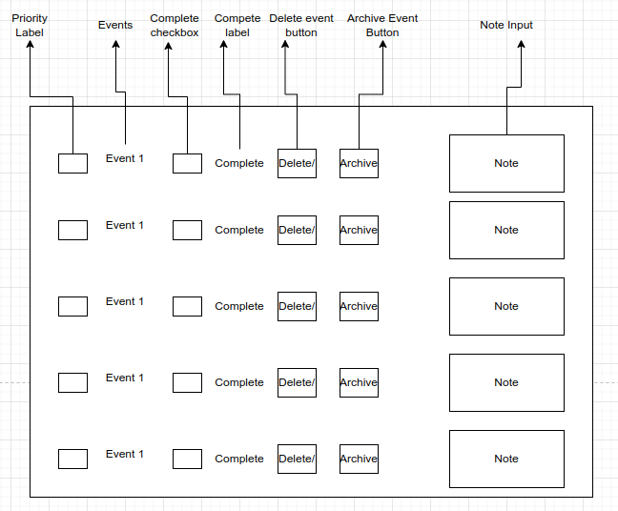

**Accomplishments for the week pertaining to the above timeline activity:**

- Achieved a layout structure

- Mapped the various elements of the project on the layout.

- Structured the categories and the contents needed for the To Do list.

**Problems that occurred and how they were solved:**

Since i have worked on python and C# on a previous courses, i could not decide on the actual language framework to use.

**Adjustments to timeline (if needed):**

Waiting for my Prof to advice on what language i can use.